**CUSTOMER JOURNEY**

Finally it results with a text message displaying that either the patient having Parkinson’s disease or not.

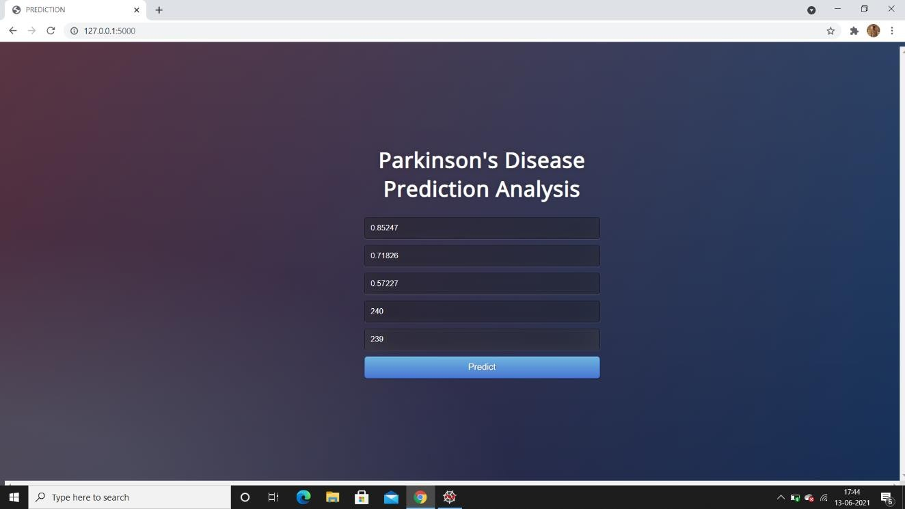

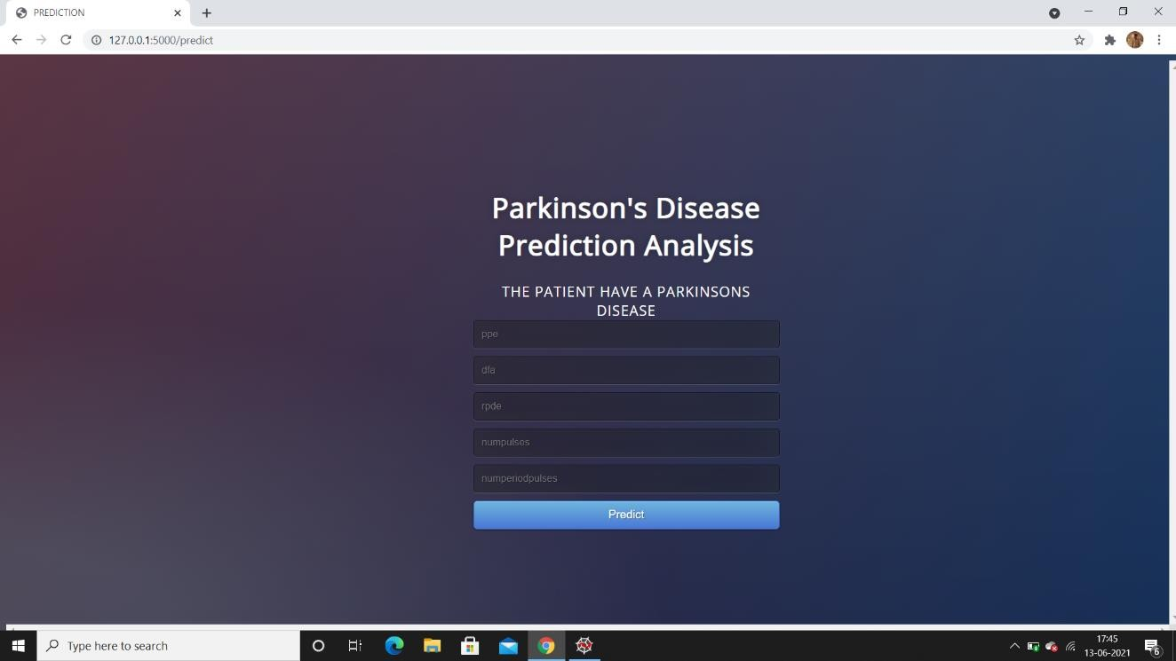**User Interface to enter the patient details**

**Predicted Result showing**

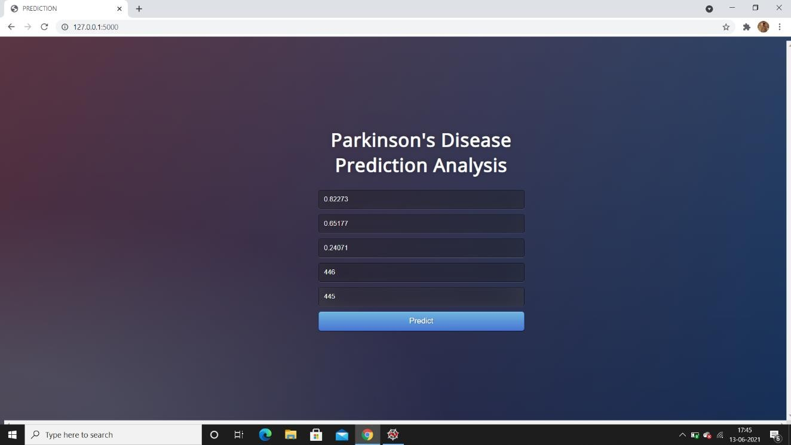

### User Interface to enter the another patient details

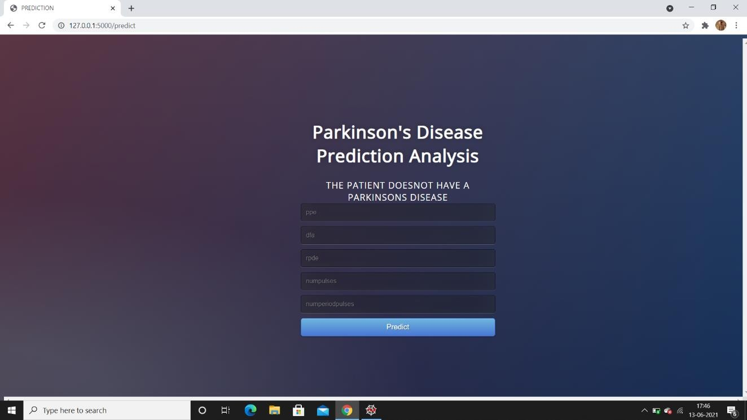

**Predicted Result showing**

The screenshots describe that we have given the data in the user interface and it is stored in a data frame. This new data will also go through all the data pre- processing steps for converting the data into the same format as that of training data set.

Now, we have used our trained model variable to make prediction on the new data and we got the predicted result i.e., the output of our system.

As like the above data, every time we want to make a prediction, we need to continue the whole process. And we gave both class prediction, one stating that “THE PATIENT HAVE A PARKINSON’S DISEASE” and another one stating that “THE PATIENT DOESN’T HAVE A PARKINSON’S DISEASE”. But many people who are not familiar with programming or python notebooks will find difficult to do the whole thing. To avoid this type of problems we have created a user interface from which everyone can just enter the details and they get to know about the report.